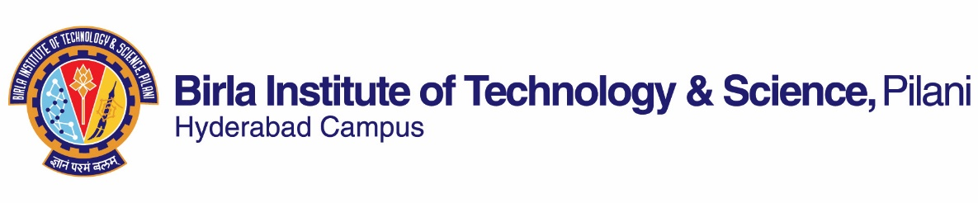

**~~FIRST~~/ SECOND SEMESTER 2021-2022**

# Course Handout Part II

Date: 15-01-2022

In addition to part-I (General Handout for all courses appended to the time table) this portion gives further specific details regarding the course.

*Course No.* :  *BITS F462*

## Course Title : RENEWABLE ENERGY

## Instructor-in-Charge : M. SRINIVAS

**Scope and Objective of the Course:**

The objective of this course is to provide introductory knowledge and a state-of-the-art learning of different sources of renewable energies including their technologies, technical assessments, socio-economic and environmental aspects pertaining to the real-world applications. Besides the theoretical knowledge, emphasis will also be provided on interactive approach to analyze the functional aspects of different renewable energy systems. The course will be useful to the students aiming to build-up and seeking better career opportunities in the field of new and renewable energy sources and related technologies.

**Textbooks:**

1. Kothari, D.P et al. Renewable Energy Sources & Emerging Tech, PHI, 2nd ed., 2011.
2. John Twidell, Tony Weir, Renewable Energy Resources, 2nd Edition, Routledge, Taylor & Francis Group, 2006.

**Reference books**

1. G.N. Tiwari and R.K. Mishra, Advanced Renewable Energy Sources, RSC Publishing, 2012.
2. Robert Ehrlich, Renewable Energy: A First Course, CRC Press, Taylor & Francis Group, 2013.

**Course Plan:**

|  |  |  |  |
| --- | --- | --- | --- |
| **Lecture No.** | **Learning objectives** | **Topics to be covered** | **Chapter in the Text Book** |
| 1-3 | Basic and introductory concepts | Energy, renewable energy, statistics, relationship between energy and social implications | T1: 1  T2: 1 |
| 4-9 | Solar energy resource and solar radiation | Components of radiation, geometry of the Earth and sun, geometry of collector, measurements of solar radiation | T1: 3, 4  T2: 4 |
| 10-14 | Solar water heating systems | Principles, types of collectors, associated heat transfer and design aspects | T1: 5  T2: 5 |
| 15-18 | Overview of solar thermal applications | Air heaters, crop driers, solar thermal storage, passive solar architecture, solar refrigeration, desalination, solar ponds, solar concentrators | T1: 5  T2: 6 |
| 19-22 | Solar photovoltaic (PV) technology and applications | Solar cell technology, cell efficiency, solar cell construction, PV circuit properties, PV applications, environmental impacts | T1: 6  T2: 7  R1: 3 |
| 23-25 | Hydropower: Resource and technology | Principles, resource assessment for small hydro installations, types of hydro turbines, social and environmental aspects | T1: 9  T2: 8 |
| 26-31 | Wind energy harnessing | Principles, Turbines and terms, fluid mechanics of wind energy and its harnessing, mechanical and electrical power generation, environmental impacts | T1: 7, 8  T2: 9 |
| 32-34 | Bio-energy resources: Biomass and biofuels | Photosynthesis, biofuel classifications and production, harnessing energy potential from biomass and biofuels, environmental aspects | T1: 12  T2: 11  R2: 5 |
| 35-36 | Wave power and Tidal power resources | Wave-motion, energy and power, wave patterns, wave power devices, causes and enhancement of Tides, power from tides, social and environmental aspects | T1: 11  T2: 12  R1: 9 |
| 37-38 | Ocean thermal energy conversion (OTEC) | Basic principles of OTEC, Heat exchangers, pumping requirements and social and environmental considerations | T1: 11  R1: 9 |
| 39-40 | Geothermal energy resource | Geophysics, harnessing energy from geothermal resources | T1: 10  T2: 15 |
| 41-42 | Renewable energy policy, opportunities and future research | Energy policies and opinions, international co-operation, career development, thrust areas of research and collaborations. | T2: 17  R2: 14 |

**Evaluation Scheme:**

|  |  |  |  |  |
| --- | --- | --- | --- | --- |
| **Component** | **Duration** | **Weightage (%)** | **Date & Time** | **Nature of Component** |
| Mid semester Test | 90 Minutes | 30 | 16/03 11.00am to12.30pm | OB |
| Surprize tests/quizzes* | 10 Minutes | 20 |  | OB |
| Written reports on assignments/projects@ | Take home | 10 |  | OB |
| Comprehensive Examination | 120 Minutes | 40 | 19/05 AN | OB |

* Best 4 out of 5. Other details would be communicated separately.

@ No of assignments/projects is one, the topic of which would be given to the students. The reports are to be submitted in hand written format. Other details would be communicated separately

**Chamber Consultation Hour:** To be announced in the class room.

**Notices:** All notices concerning this course shall be displayed on the CMS (the Institute’s web based course management system). Besides this, students are advised to visit regularly CMS for latest updates.

**Make-up Policy:** Make-up shall be given only to the genuine cases with prior confirmation. Request for the make-up tests, duly signed by the students, should reach the under signed well before the scheduled test.

**Academic Honesty and Integrity Policy:** Academic honesty and integrity are to be maintained by all the students throughout the semester and no type of academic dishonesty is acceptable.

**Instructor-in-Charge**

**BITS F462**